**Mining Allocation**

**User Guide**

**Iteration 1**

**Full hashpower conversion feature available for Users**

Table of Contents

My Plans 1

Dashboard Overview 2

Allocation of TH/s 3

Buy Plan 3

My Wallet - Pay It Forward 5

FAQ 5

# My Plans

On the left side menu there is **My plans** tab which includes two sections:

* Bitcoin Vault (BTCV)
* Bitcoin (BTC)

In **Bitcoin Vault/Bitcoin** section there is a new dashboard which presents how much hash power Users have in their BTCV and BTC plans. The Total Hashrate is a sum of all BTCV or BTC plans depending on the Users’ purchase.

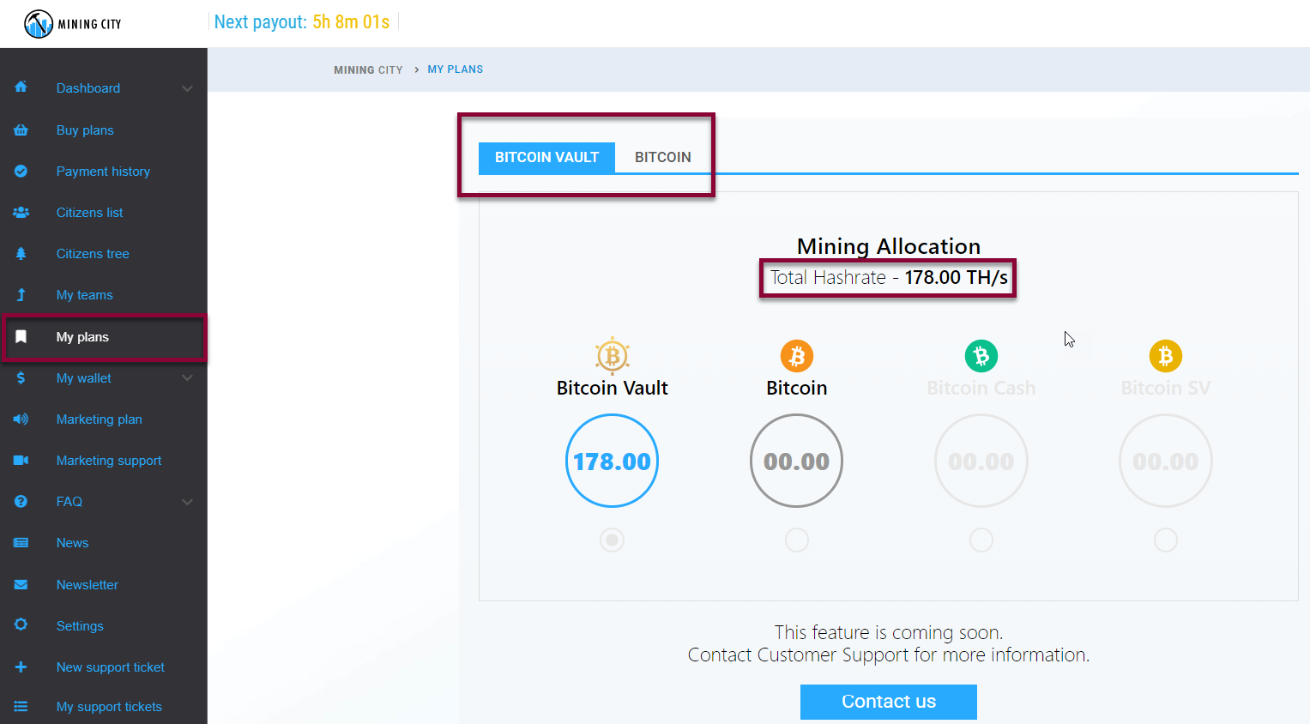

# Dashboard Overview

The dashboard consists of:

1. **Bitcoin Vault and Bitcoin sections**

The User can switch between BTCV and BTC sections by clicking on the respective tabs. After clicking on the tab, Mining Allocation dashboard appears.

1. **Total Hash Power Counter**

The Total Hashrate is a sum of all BTCV or BTC plans depending on the Users’ purchase.

1. **Cryptocurrencies available**

Below the total hash power counter, there are four different cryptocurrencies (Bitcoin, Bitcoin Vault, Bitcoin Cash, Bitcoin Satoshi Vision) with their logotypes. Under each logo there is a circle with an amount of TH/s that mine a specific coin.

1. **Selection radio button**

Selection radio button enables a User to choose a cryptocurrency (s)he wants allocate TH/s to. For instance, if a User wants to allocate all TH/s bought in BTCV plans to mine BTC, (s)he needs to click a radio button under the Bitcoin cryptocurrency

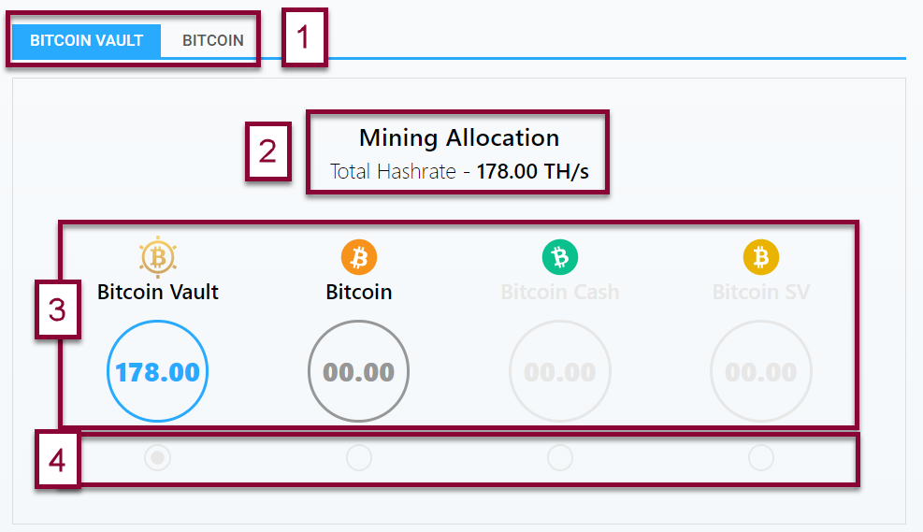

# Allocation of TH/s

If a user wants to allocate TH/s to a specific cryptocurrency, (s)he needs to:

1. Select a radio button to choose a cryptocurrency (s)he wants allocate TH/s to
2. Select the [Confirm] button to confirm the requested change

For instance, if a User wants to allocate all TH/s bought in BTCV plans to mine BTC, (s)he needs to click a radio button under the Bitcoin cryptocurrency. Then, the [Confirm] button becomes active and a User clicks it to confirm the requested change.

1. A pop-up with Terms & Conditions appears. In order to confirm the changes, a User has to check the box and agree to MC T&Cs. Once the T&Cs are accepted, a blue bar appears on the screen stating that the conversion might take up to 48 hours. If a User does not want to proceed with the changes, (s)he can always click on the [Cancel] button and stop the process of allocation.

A User can change the mining allocation after two days counted from the end of a conversion period. There is a blue bar (counter) visible on the dashboard informing a User in how much time (s)he will be able to make new changes.

**Please note**:

* In Iteration 1 a User can allocate their total hash power to mine only one cryptocurrency, either Bitcoin or Bitcoin Vault. Two other cryptocurrencies - Bitcoin Cash and Bitcoin Satoshi Vision - are not available yet.

# 

# Buy Plan

A User, when buying a new plan, can select which cryptocurrency (s)he wants to mine.

To buy a currency, a User:

1. Enters My plans tab

2. Clicks the [Buy Plan] button

3. Selects which cryptocurrency (s)he wants to mine.

If a User buys a BTC plan, BTC coin is selected by default. A User can select BTCV plan to mine BTCV coins.

1. Clicks the [Confirm selection] button

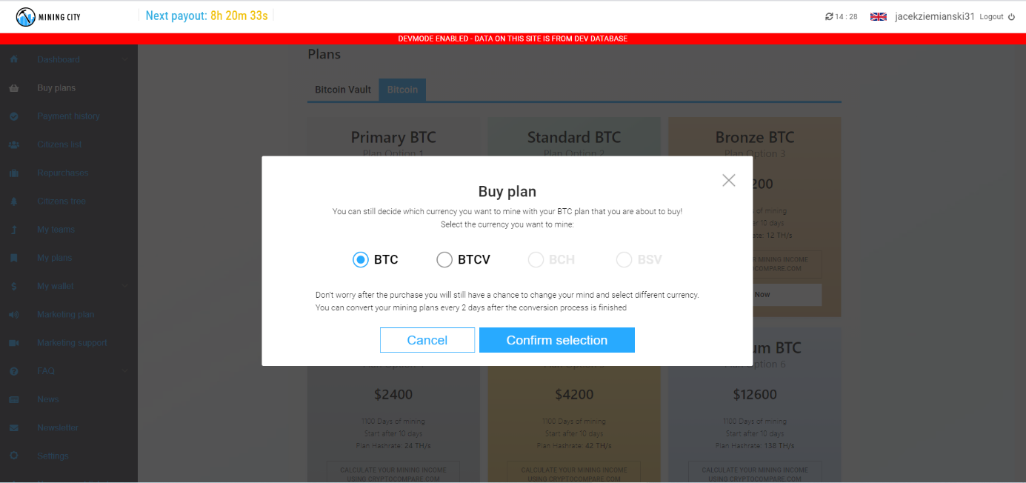

1. Agrees to Terms & Conditions which appear in the pop-up

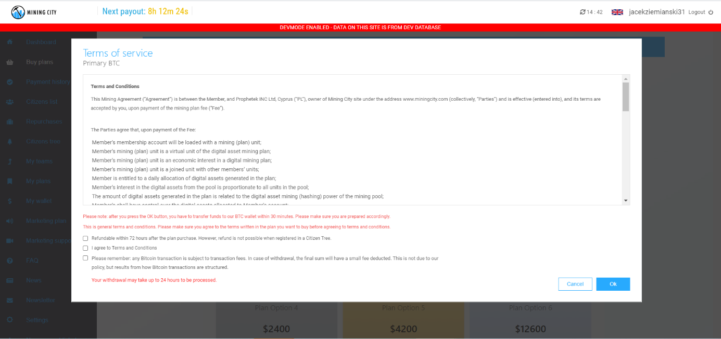

1. Once the T&Cs are accepted, a sum-up pop-up appears stating which plan a User is about to buy, which cryptocurrency this plan will be mining, and who will be the owner of the plan.

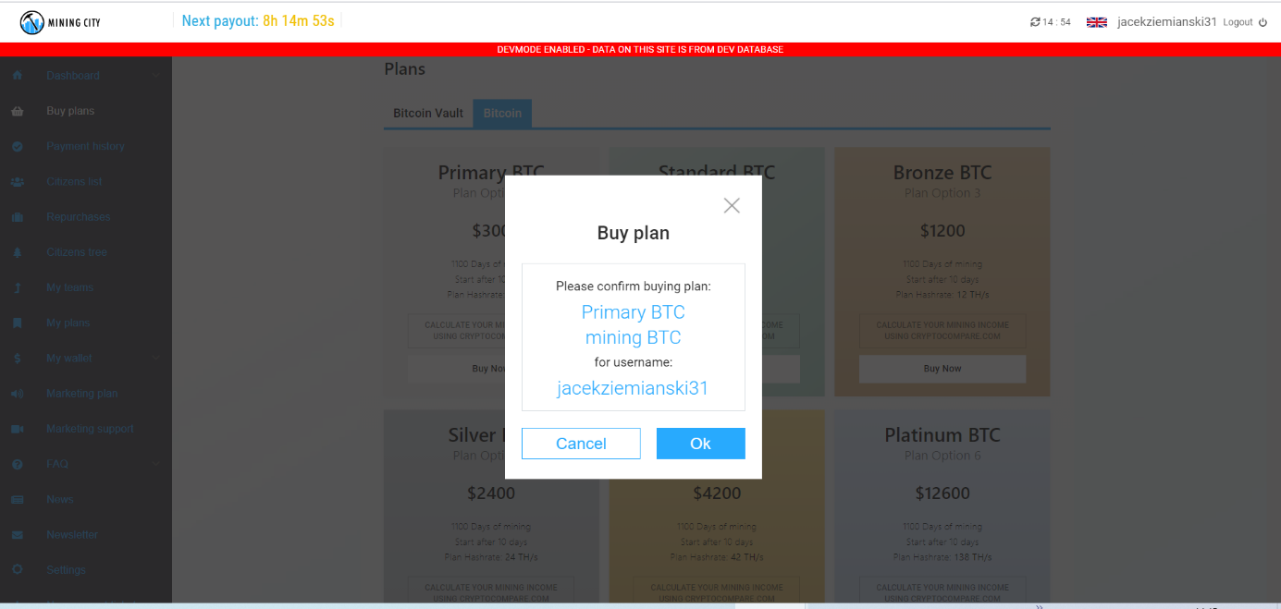

**Please note**:

* In Iteration 1 there are only two cryptocurrencies available: BTCV and BTC. The two new cryptocurrencies - Bitcoin Cash and Bitcoin Satoshi - are not available yet.
* You will be able to change your mining allocation after two days from the purchase.

# My Wallet - Pay It Forward

In **My wallet** tab, when the User wants to make a **Pay it forward** purchases a new field is added – “Please select the cryptocurrency the product should mine”. It means that if a User buys a BTCV Standard Plan, (s)he can still select to mine BTC with all TH/s in this plan or if (s)he prefers to - select BTCV.

Please note:

* Selecting cryptocurrency in this field is obligatory.
* In Iteration 1 there are only two cryptocurrencies available for selection: BTCV and BTC. The two new cryptocurrencies - Bitcoin Cash and Bitcoin Satoshi - are not available yet.

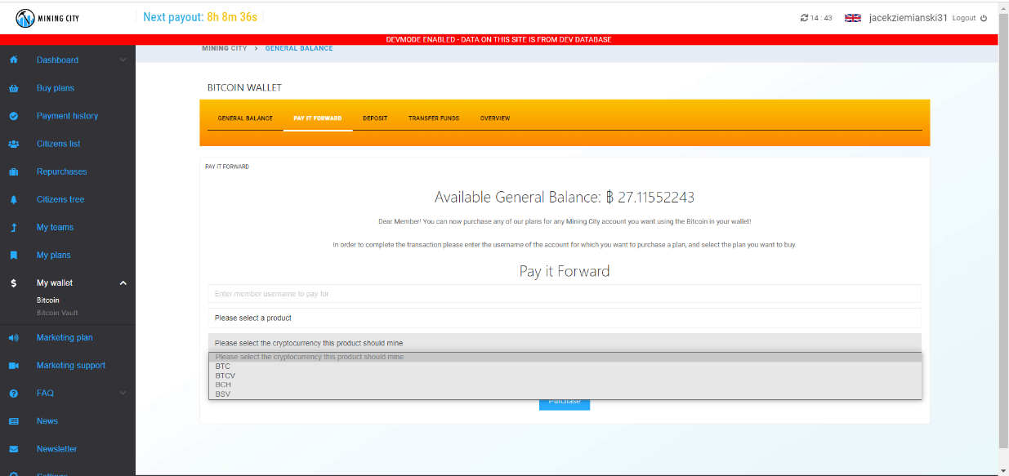

# FAQ

1. Can I allocate my TH/s at any time I want?

You can allocate your mining hash power every 2 days counted from the end of conversion process. There is always a bar informing if you cannot make the allocation.

1. Can I allocate my TH/s to mine Bitcoin Cash?

Currently, this cryptocurrency is not available but once it is, we will inform you.

1. Can I allocate my TH/s to mine Bitcoin Satoshi?

Currently, this cryptocurrency is not available but once it is, we will inform you.

1. How can I change allocation of TH/s that I have just bought?

When you buy a new mining plan you can select which cryptocurrency you want to mine. Basically, it means that even if you buy a BTCV Standard plan, this plan can mine BTC. It works the same way for BTC plans, so if you buy a BTC Gold plan, you can still select BTCV to be mined during purchase process.

1. Can I mine a different coin than the mining plan I bought?

Yes, you can. You can allocate all your hash power from BTCV plans to mine BTC and you can do the same for BTC plans so that they mine BTCV.

1. Can I select a coin that should be mined when I execute a PIF?

Yes, you can. There is one more additional field added in the “Pay it forward” tab. After you select the User for whom you want to buy a plan and a plan itself, you need to select which cryptocurrency this plan should mine.

1. Can I change mining allocation of a plan that another User bought as PIF for me?

Yes, you can. You can change it after 2 days from the purchase as long as your other plans are not in post-conversion period.